**Log into Hyperspace to Cosign Orders in In Basket**

1. To access the Hyperspace Environment, you will need to click on the Tufts medicine icon on your desktop.



1. You will be prompted to login to Tufts Medicine Citrix. User your email and password. You can Click Always allow on the boxes that pop up so you don’t have to allow every time.

1. Then click on EPIC PRD. This is the production environment of hyperspace.

1. Next you will login to EPIC. Here you can use your email or your six digit EPIC ID.

1. You will have to choose the login department of TMCAH SCHEDULING when logging into Hyperspace for the first time. You can Click the magnifying glass and search TMCAH Scheduling. **All of Tufts Care are home is this department.** Click Accept and Continue.

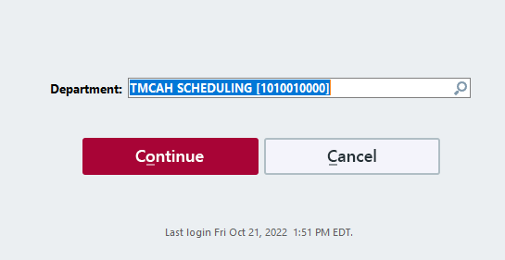

1. Navigate to your In Basket Workspace tab.
2. Click on the Cosign - Clinic Orders folder. **This folder will only appear when there are new messages, if you do not see this folder, no orders have been assigned to you to cosign.**
3. Select the individual message to view order details and click Sign when ready.

In Basket