**Home Care Address and Place of Service**

The schedulers will now have access to update patient’s address. To update a temporary address this change must be documented in both the Home Care address and Place of Service. The clinicians have access to make this change in remote client and there is a tip sheet for them as well.

Please note if this is a permanent address change, meaning this is the patients address not just where they are staying and getting services now, this can only be done in hyperspace by a manager or scheduler and a clinician will have to notify you. To change a permanent address, the Home Care address, Place of Service and the address in Demographics needs to be updated.

**First Updating the Home Care Address**

1. Go to intake and search the patient.
2. Click the Care Team Information.
3. Then update the new address.

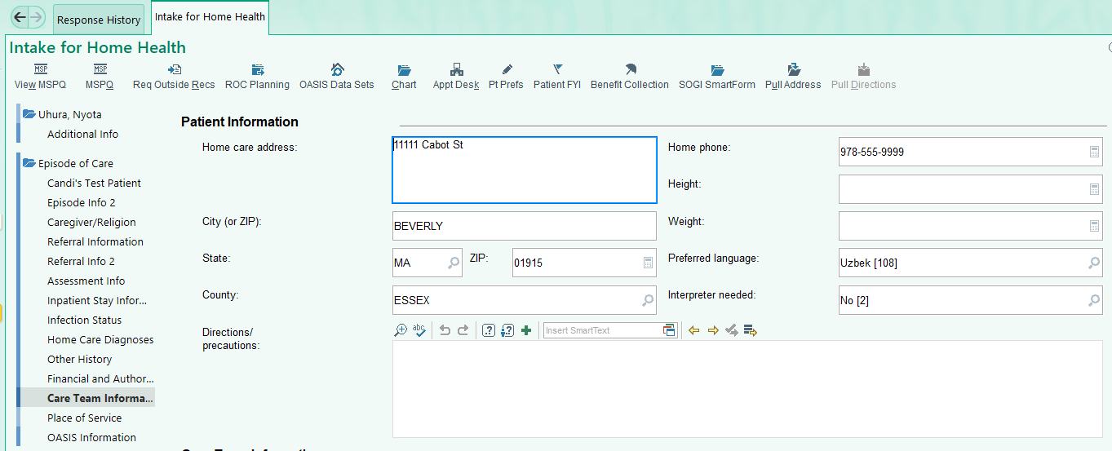

**Then Updating the** **Place of Service**

1. Click Place of Service.
2. Then Click update and enter the new address.

**If this is a permanent address change you must also update the address in demographics.**

1. Underneath the first section in Intake, click on the patient’s name.
2. Then Click Demographics in the middle.
3. And when the Demographics box comes up, edit the permanent address tab.

**1**

**3**

**2**