Home Care Address and Place of Service
To update a patient’s temporary address In Remote Client, both the Home Care Address and Place of Service Entry need to be updated.
Please note if this is a permanent address change, meaning this is the patients address not just where they are getting services now, this can only be done in hyperspace by a manager or scheduler.

First updating the Home Care Address
- Click on the Address Book Task.
- Click on the Address/Directions Tab under Patient Tab.
- The Driving/Precautions Box is where additional information can be documented in the for other clinicians to view either on the Remote Client in the Thumbnail or Rover.
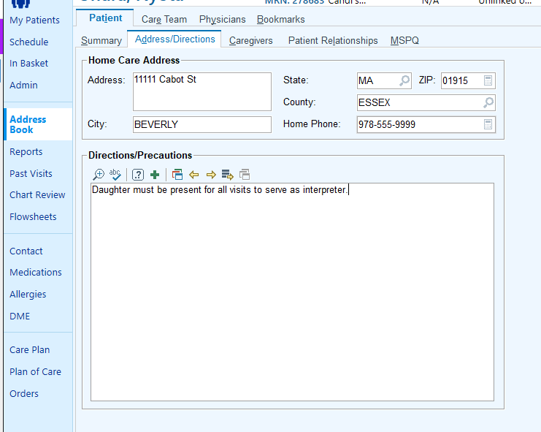
2
3
1

Then updating The Place of Service
- For Home Health patients The Place of Service can only be updated within an encounter/contact.
- In the form Place of Service Entry.
- Click Update and enter new address.
3
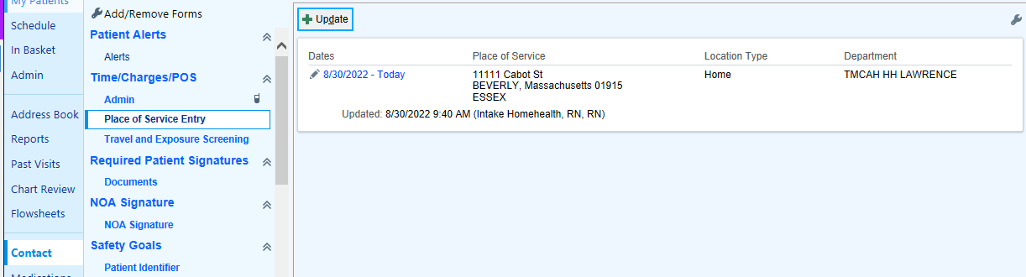
2
1

- For Hospice patients, The Place of Service can be updated from the Hospice Info task or within an encounter/contact.
- Click the Hospice Info Task.
- Click on the Place of Service Tab.
- Click Update and enter new address.
2
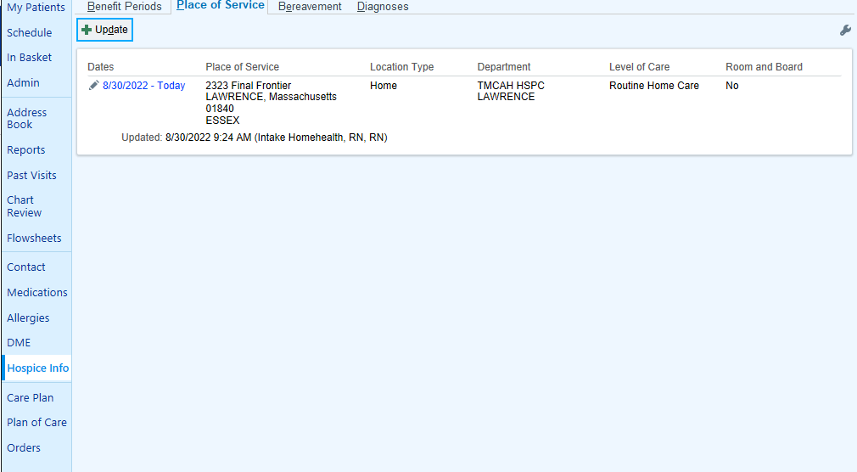
3
1

